Exercise IV
- For the common-emitter amplifier shown in Fig.1.1. The transistor has 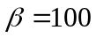. Calculate the DC bias current . Replace the transistor with its hybrid model and draw the amplifier equivalent circuit. Find the values of 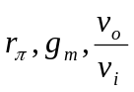and 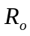.
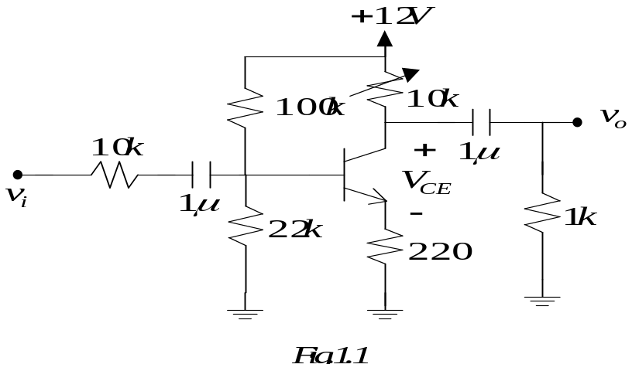
- In the common-collector amplifier of Fig.1.2, 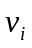 is a small sine wave signal with zero average value. The transistor has, find the gain 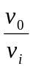.
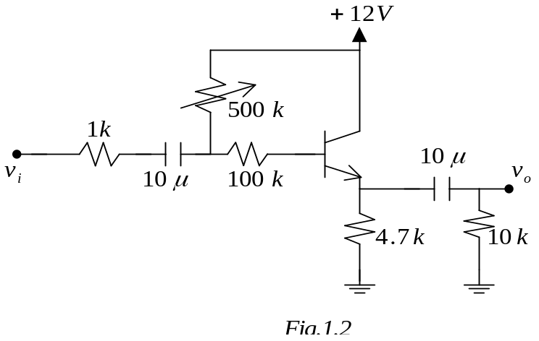
- For the common-base amplifier shown in Fig.1.3. The transistor has . Calculate the DC bias current . Find the values of 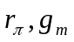 and 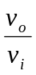.
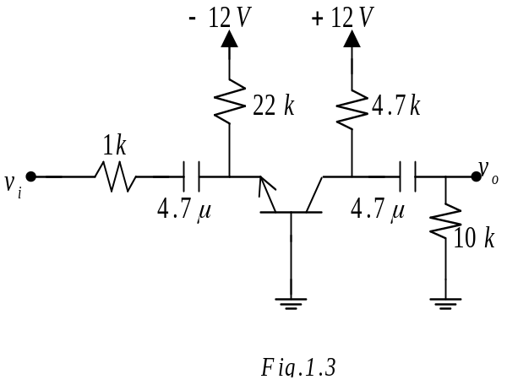
4. Consider the following circuit. Let 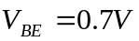, 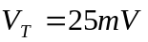 and . Find the input resistance 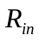 by using hybrid T model.

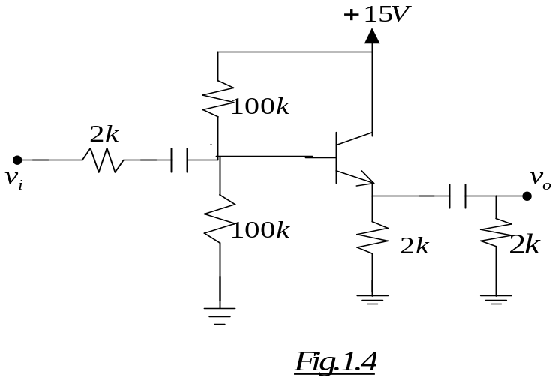
- Consider the CE amplifier of Fig.1.5. Let BJT have the following hybrid model (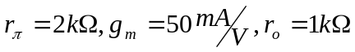 ). Find the AC gain . Neglecting , recalculate the AC gain .
